Webserivce – REST & SOAP

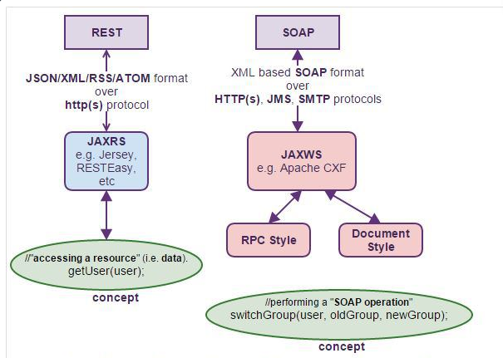

Difference between REST and SOAP?

1) REST is more simple and easy to use than SOAP
2) REST uses HTTP protocol for producing or consuming web services while SOAP uses XML.
3) REST is lightweight as compared to SOAP and preferred choice in mobile devices and PDA's.
4) REST supports different format like text, JSON and XML while SOAP only support XML.
5) REST web services call can be cached to improve performance.

TopDown and bottomUp approach in webservice?
TopDown : - wsdl is created and then java class is developed from wsdl, so if any changes done in wsdl then again need to change java file again.
BottomUp : From java file wsdl is created using annotation like @ webservice.

RestFull resources are accessed by multiple clients
Since a new Resource instance is created for every incoming Request there is no need to make it thread-safe or add synchronization. multiple client can safely access RestFull resources concurrently.

Restful Client Example
String uri =
"http://www.example.com/customers/1";
URL url = new URL(uri);
HttpURLConnection connection =
(HttpURLConnection) url.openConnection();
connection.setRequestMethod("GET");
connection.setRequestProperty("Accept", "application/xml");

JAXBContext jc = JAXBContext.newInstance(Customer.class);
InputStream xml = connection.getInputStream();
Customer customer =
(Customer) jc.createUnmarshaller().unmarshal(xml);

connection.disconnect();

Rest Client Example
Jersey api client used for rest for my project.
import com.sun.jersey.api.client.Client;
import com.sun.jersey.api.client.ClientResponse;
import com.sun.jersey.api.client.WebResource;

Key logics :
Client client = Client.create();
WebResource webResource = client.resource(url+"/job/"+jobName+"/doDelete");
ClientResponse response = webResource.post(ClientResponse.class);
String jsonResponse = response.getEntity(String.class);
client.destroy();
return jsonResponse;

